**Assignment 8 : Group B (Unit III & IV )**

|  |  |  |  |  |  |  |
| --- | --- | --- | --- | --- | --- | --- |
| **W (4)** | **C (4)** | **D (4)** | **V(4)** | **T (4)** | **Total** | **Sign** |
|  |  |  |  |  |  |  |

**Date of Performance ____________**

**Date of Completion** :_____________

**Problem Definition:**

**Problem Definition :Use packet Tracer tool for configuration of 3 router network using one of the following protocol RIP/OSPF/BGP** 

* **Prerequisite**

1. Routing Protocols.

2. Basics of Packet Tracer.

* **Learning Objectives**:

1. To Understand Simulation Tool.

2. Should Able to Configure Routing Protocols

* 1. **Theory:**
     1. **Introduction**

**ROUTING INFORMATION PROTOCOL**:

The **Routing Information Protocol** (**RIP**) is one of the oldest distance-vector routing protocols which employ the hop count as a routing metric. RIP prevents routing loops by implementing a limit on the number of hops allowed in a path from source to destination. The maximum number of hops allowed for RIP is 15, which limits the size of networks that RIP can support. A hop count of 16 is considered an infinite distance and the route is considered unreachable. RIP implements the split horizon, route poisoning and holddown mechanisms to prevent incorrect routing information from being propagated.

Originally, each RIP router transmitted full updates every 30 seconds. In the early deployments, routing tables were small enough that the traffic was not significant. As networks grew in size, however, it became evident there could be a massive traffic burst every 30 seconds, even if the routers had been initialized at random times. It was thought, as a result of random initialization, the routing updates would spread out in time, but this was not true in practice. Sally Floyd and Van Jacobson showed in 1994 that, without slight randomization of the update timer, the timers 

synchronized over time.

**OPEN SHORTEST PATH FIRST: (OSPF)**

* OSPF is an interior gateway protocol (IGP) for routing Internet Protocol (IP) packets solely within a single routing domain, such as an autonomous system. It gathers link state information from available routers and constructs a topology map of the network. The topology is presented as a routing table to the Internet layer which routes packets based solely on their destination IP address.
* Open Shortest Path First (OSPF) is a routing protocol for Internet Protocol (IP) networks. It uses a link state routing (LSR) algorithm and falls into the group of interior gateway protocols (IGPs), operating within a single autonomous system (AS).

**CONFIGURE ROUTING INFORMATION PROTOCOL (RIP)**

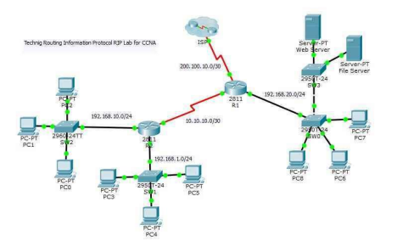

Open the router 1 (**R1**) which is the main router connected to ISP router. Do the following command for RIP Routing.

R1>enable

R1#configure terminal

Enter configuration commands, one per line. End with CNTL/Z.

R1(config)#router rip

R1(config-router)#version 2

R1(config-router)#network 200.100.10.0

**DHCP message types:**

R1(config-router)#network 192.168.20.0

R1(config-router)#network 10.10.10.0

R1(config-router)#

After enabling router with enable command then go to privileged mode with configure terminal command. Now with router rip command, enable routing for all routers. The version 2 Command, configure routing information protocol with version two. And next set all network id like the above network command. I have set all three network which connect directly to R1.

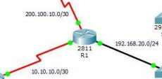

Now go to router R2 and configure routing protocol the same as router R1. On router 2 you must assign the network ids of all connected network the R2.

R2>enable

R2#configure terminal

Enter configuration commands, one per line. End with CNTL/Z.

R2(config)#router rip

R2(config-router)#version 2

R2(config-router)#network 10.10.10.0

R2(config-router)#network 192.168.10.0

R2(config-router)#network 192.168.1.0

R2(config-router)#

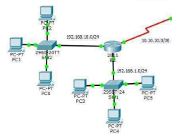

For ISP router, just enter the network id 200.100.10.0, because only one network connected to ISP router.

ISP>enable

ISP#configure terminal

Enter configuration commands, one per line. End with CNTL/Z.

ISP(config)#router rip

ISP(config-router)#version 2

ISP(config-router)#network 200.100.10.0

ISP(config-router)#

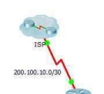

**CONFIGURE OSPF ROUTING PROTOCOL**

In the router R1 configure OSFP routing with Router ospf command.

R1>enable

R1#configure terminal

Enter configuration commands, one per line. End with CNTL/Z.

R1(config)#router ospf 1

R1(config-router)#network 20.10.10.0 0.0.0.3 area 0

R1(config-router)#network 10.10.10.0 0.0.0.3 area 0

R1(config-router)#network 10.10.10.4 0.0.0.3 area 0

R1(config-router)#

The router OSPF command is enable OSPF routing on the router, and the 1 before OSFP is the process ID of the OSFP Protocol. You can set different process id from “1-65535” for each router.

The network command with network ID “network 20.10.10.0” is the network identifier, and the “ 0.0.0.3″ is the wildcard mask of 20.10.10.0 network. Wildcard mask determine which interfaces to advertise, because OSPF advertise interfaces, not networks.

Now go to Router R3 and configure with the following commands.

*R3>***enable**

*R3#***configure terminal**

*Enter configuration commands, one per line. End with CNTL/Z.*

*R3(config)#***router ospf 1**

*R3(config-router)#***network 192.168.1.0 0.0.0.255 area 0**

*R3(config-router)#***network 10.10.10.0 0.0.0.3 area 0**

Don? So do the following for router R2.

*R2>***enable**

*R2#***configure terminal**

*Enter configuration commands, one per line. End with CNTL/Z.*

*R2(config)#***router ospf 1**

*R2(config-router)#***network 192.168.10.0 0.0.0.255 area 0**

*R2(config-router)#***network 10.10.10.4 0.0.0.3 area 0**

OK, OSPF routing configuration has been finished successfully, now test your network whether they can ping with each other or not.

**Assignment Questions:**

**1.** Explain Routing Protocols in Details?

**2.** Draw Classification Diagram of Routing Protocols? **3.** Explain Packet Tracer Routing Commands?

**4.** Difference between RIP & OSPF?

5. Key differences between RIPv1 and RIPv2?

**Conclusion:**

Hence we have studied Packet Tracer Properly.